Basic Badminton Terms

Service
- Server/ Receiver: The person who delivers the badminton serve is called the "server" while the person receiving the serve is called the "receiver".
- "Long" or "Short" During a badminton serve, we usually say LONG/SHORT instead of IN/OUT if the shuttle falls outside the boundaries of the receiver's area.
If the shuttle falls outside the boundaries AT THE FRONT of the court we call it "short".
If the shuttle falls outside the boundaries BEHIND the court we call it "long".
If the shuttle falls outside the boundaries at the side of the court, just call it "out".
- Service Over: If you made a serve and lost the rally, it will be called SERVICE OVER. That means that it's your opponent's turn to make a service for the next rally.

Lets
- Lets: given when receiver is not ready.
When a 'let' is given, no points will be offered to both parties for that particular rally.
The umpire calls for the rally to be replayed when a 'let' is given.

Scoring Terms
- Love: In badminton, 0 points is called "love".
- All: If both teams' scores are level, we say ALL behind the points. For example, if the score is 2 - 2, we say 2 ALL.
The score of the server will be mentioned first. For example, your score is 2 and your opponent's score is 5. Say you won the last rally. So you are the server for this rally, therefore the points will be stated as 2 - 5.
- DEUCE: If the score ever reaches 20-20, the game will be "deuce". This means that either one party must lead by 2 points to win the game. See the badminton scoring system for more information on this.

Badminton Court Lines
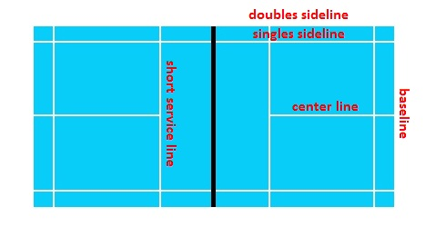
The picture above shows the name of the lines in a badminton court expressed in badminton terms.
"Baseline Smash" is a common used in badminton language, indicating a jump smash from the back end of the court.

Badminton Shots
- Badminton CLEAR or badminton LOB refers to hitting the shuttle high up to the back of your opponent's court.
- Badminton DROP means aiming the shuttle to drop to the front area of your opponent's court. Usually this is done from the back end of your side of the court.
- Badminton SMASH means using extreme power to pin the shuttle down to your opponent's court.

Rally
A rally is referred to a badminton point. For example, if you win a point, you are said to have won a rally.

Rubber
A rubber game is a third deciding set in a badminton match.
When both players won one set each, they will have to enter into a 3rd deciding set to determine the winner. This 3rd set is called the rubber or rubber game.

