Progressive Tennis

Object
The object of the game is to hit the ball over the net so that it bounces in the opponent's court in such as way that the opponent can't return it over the net.

Playing Area

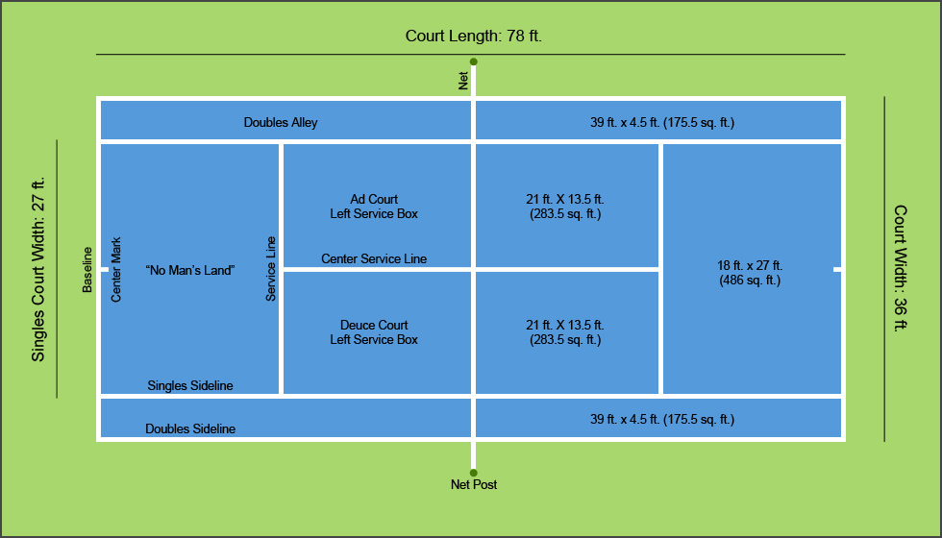
The court is rectangular in shape and can have a variety of surfaces: clay, grass, asphalt, porous concrete or other material.
A 3½ ft-high net splits the court in half.

Duration
In the men's game, a tennis match is over when one of the players wins 3 out of 5 sets. For women, the match concludes when someone wins 2 out of 3 sets. In physical education class games are timed either 5 minutes or 10 minutes in length.

Starting Play
Singles tennis is played with 1 player on opposite sides of the net. For doubles play, 2 players line up on each side of the net.
A coin toss determines who serves first and which side of the net each player will start on. The winner of the toss may choose her preference of service or side.

Scoring
Points: It takes 4 points to win a game, and the tennis scoring goes like this:
"Love – 15 – 30 – 40 - Game".
Each player begins with a score of 0, known as "Love." The first time a player wins a point, she has 15. If she wins a second point, she has 30. If she wins a third point, her score is 40. On the next point, she wins the game. There is an exception, though:
Game: A player must win by 2 points to win the game. If both players have earned 3 points, the score is 40-40 which is called "Deuce." The player who wins the next point has "advantage." If the player with "advantage" wins the next point, she wins the game. If she loses the next point, the game goes back to Deuce. Play continues in this fashion until someone wins 2 points in a row to gain a 2-point lead.
When saying the score, the Server's score is always given first. For example, a score of "40 - 15" means the Server has 3 points, and the Receiver has 1 point.
Set: The first player to win 6 games wins the set, except in the following situation:
If the players are tied at 5 games each, they must play until a player wins 2 games in a row to gain a 2-game lead.
Match: For men, a player has to win 3 out of 5 sets to win the match. For women, winning 2 out of 3 sets is required to win the match.
In physical education class the score is counted 1,2,3,and so on until 21 pts or until the end of the determined length of time per game.

Losing a Point
A player loses a point if she:
- fails to return the ball over the net before it touches the ground twice on her side of the net.
- returns the ball so that it hits out of bounds on the opponent's side of the court.
- hits the ball into the net.
- hits the ball twice.
- is hit by the ball anywhere other than on her racket.
- touches the net with her racket or any part of her body.
- touches the ground on her opponent's side of the net.
- throws her racket to hit the ball.

Good Return
A return is good if:
- it bounces inside the court after crossing the net.
- the ball touches the net or crosses outside the center posts as long as it lands in the correct court.
- a player's racket reaches over the net after hitting the ball as long as the player did not hit the ball before it crossed the net.
- the ball lands on a boundary line.

Service
To serve, the ball is thrown into the air and struck with the racket before it hits the ground. The ball has to cross the net without bouncing and land in the service court (diagonally opposite from the Server.) If the ball lands on a line, it's a good serve.
If the first serve is not good, the Server gets a second serve. If that serve fails to go over properly, the Server loses a point.
If the serve hits the net and falls into the appropriate court on the opponent's side, a "let" is called, and the Server serves the ball again. There's no limit to the number of lets that a Server can have. The Server continues serving in the same court until he either makes a good serve or gets 2 faults.
The service is a fault if:
- the server swings at the ball and misses it while attempting to serve.
- the ball doesn't land in the proper service court.
- the ball touches any permanent fixture other than the net.
After the first fault, the Server shall serve again from behind the same half of the court. After the second fault, the Server loses a point, and he moves to the other side for his next serve.
The Receiver may stand wherever he wants to on his side of the net, but the ball must hit the ground on the serve before he may return it.
In physical education class we rotate the serve Douce Court Team A, Deuce court side Team B, Ad Court Team A, Ad Court Team B and so on.

