Basic Badminton Rules

1. Badminton Scoring System
Badminton scoring is based on the 21 point, rally point system.
Whether its badminton singles or doubles, whichever team reaches 21 points first will be the winner of the game. You must win by two points.

Winning/ Losing Points
You get a point by winning a rally.
You win a rally if the shuttle drops within the INSIDE boundaries of your opponent's side of the court.

Badminton Scoring and Serving Position for SINGLES
You should also know which area on the court you should be standing when making a service. It's very simple.
The player making a service serves diagonally to the opponent's side. Serve to the gray coloured area. Anywhere outside the gray area is considered to be OUT.
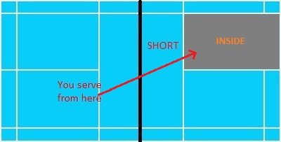
The player with an:
- EVEN number score (2,4,6,8...) will serve from the RIGHT hand side area of the court.
- ODD number score (1,3,5,7...) will serve from the LEFT hand side of the court.
A simple illustration is provided in the picture below.
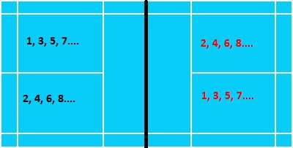

Badminton Scoring and Serving Position for DOUBLES
The serving position in doubles is the same as in singles. The only difference is that one side will have 2 players.
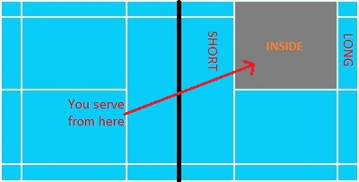
I'll just provide a simple example to explain it clearly.
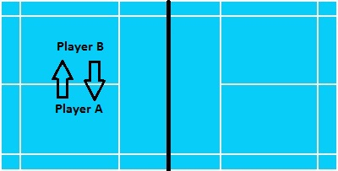
Badminton players only switch areas when the party making the serve wins consecutive points.
Still don't get it?
Don't worry! It's pretty simple. Here are examples of 2 possible scenarios...
One team will have 2 players (player A and Player B). The score is 0-0 and the team will start the game by making the first badminton service.

Scenario 1:
In the above picture, "player A" stands at the right hand side and their current point is 0, so "player A" will serve from the right side.
If the team WINS the rally, the point will be 1-0 and "player A" will have to move to the left hand side of the court. "Player B" moves to the right hand side (i.e. both of them switch places).
Now, "Player A" will make the service from the left side.

Scenario 2:
Let's go back to 0-0. Say "player A" starts the service. But this time, they LOSE a point to the opposing team. The score is 1-0. The opponent gets to serve now.
Then during the next rally, "player A's" team WINS THE POINT BACK and gets 1-1. This time, "player B" serves** instead of "player A" (They DO NOT need to switch areas).
**Since 1 is an odd number, the player standing at the left hand side of the court will make the service.

2. Badminton Fouls
There are three common badminton fouls:
a. "Over the Net" fouls
b. "Service" fouls
c. "Contact" fouls

A. Over the Net
During a badminton game, you (and your racquet) are not allowed to:
- go over the badminton net to your opponent's side of the court
- touch the net. Failure to comply will result in you LOSING a point unnecessarily to your opponent.

B. Service Fouls
When you are about to make a service in a ready position:
- The racquet head MUST be below your waist.
- The racquet MUST swing UPWARDS when the service is being delivered.
- Upon contact between the shuttle and the racquet, the flight of the shuttle must head upwards until it passes the net

C. Avoid Contact
As mentioned above, you (and your racquet) are not supposed to touch the badminton net. Besides this, you are not allowed to touch the shuttle. ONLY your racquet can come into contact with the shuttle. Even if the shuttle touches your shirt, pants, leg, etc, it is still a foul.

3. In/Out Boundaries for Badminton Singles
Before performing a serve , you should know the terms "LONG" and "SHORT".
- "Long" refers to the shuttle landing at the OUTSIDE area at the back of the court.
- "Short" refers to the shuttle landing at the OUTSIDE area at the front of the court.
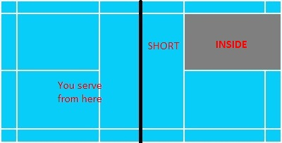
The gray area in the above picture shows you the area that is considered INSIDE for a badminton service.
After a badminton service (i.e. during the game), the long/short rules do not apply.
The yellow area in the above picture shows you the area that is considered INSIDE during the normal course of a badminton game after a service has been made.
If the shuttle so happens drop ON the in/out line (borders of the coloured area in the pictures above), it will still be considered as dropping INSIDE the court.

In/Out Boundaries for Badminton Doubles
The correct area to stand in while delivering a badminton service is illustrated below:
The picture above shows the area that is considered INSIDE for a badminton serve in a badminton doubles game.

In/Out Rules (During the Game)
The picture above shows the area that is considered INSIDE during a badminton game after the service has been delivered in a badminton doubles game.

